**Peer-graded Assignment: Analyzing Historical Stock/Revenue Data and Building a Dashboard**

***Name: Juan Francisco Araujo Bayas***

Summary Table

**Beginning of code to answer to the different questions:** 2

**Question 1: Use yfinance to Extract Stock Data (Extracting Tesla Stock Data Using yfinance)** 2

**Question 2: Use Webscraping to Extract Tesla Revenue Data (Extracting Tesla Revenue Data Using Webscraping)** 3

**Question 3: Use *yfinance* to Extract Stock Data (Extracting GameStop Stock Data Using yfinance)** 6

**Question 4: Use Webscraping to Extract GME Revenue Data (Extracting GameStop Revenue Data Using Webscraping)** 7

**Question 5: Plot Tesla Stock Graph (Tesla Stock and Revenue Dashboard)** 9

**Question 6: Plot GameStop Stock Graph (GameStop Stock and Revenue Dashboard)** 9

# **Beginning of code to answer to the different questions:**

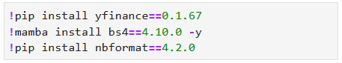

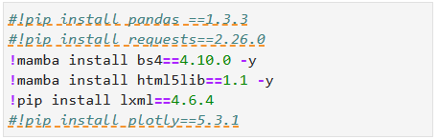

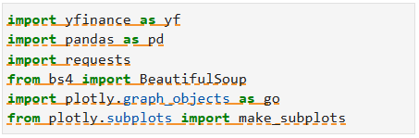

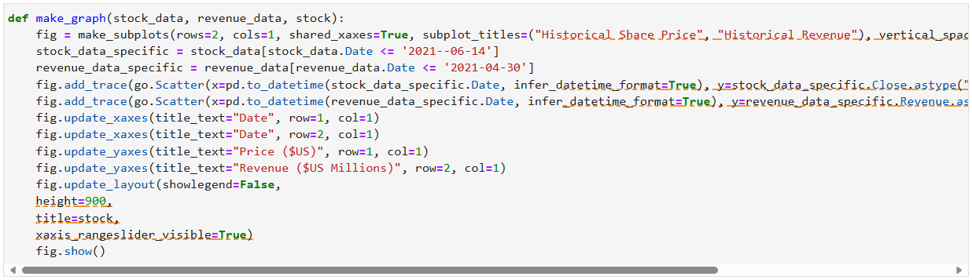

# **Question 1: Use yfinance to Extract Stock Data (Extracting Tesla Stock Data Using yfinance)**

Using the Ticker function enter the ticker symbol of the stock we want to extract data on to create a ticker object. The stock is Tesla and its ticker symbol is TSLA.

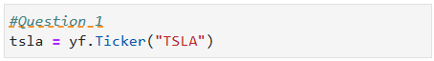

Using the ticker object and the function history extract stock information and save it in a dataframe named tesla_data. Set the period parameter to max so we get information for the maximum amount of time.



**Reset the index** using the reset_index(inplace=True) function on the tesla_data DataFrame and display the first five rows of the tesla_data dataframe using the head function. Take a screenshot of the results and code from the beginning of Question 1 to the results below.





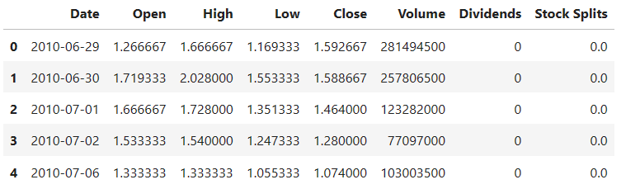

# **Question 2: Use Webscraping to Extract Tesla Revenue Data (Extracting Tesla Revenue Data Using Webscraping)**

Use the requests library to download the webpage <https://cf-courses-data.s3.us.cloud-object-storage.appdomain.cloud/IBMDeveloperSkillsNetwork-PY0220EN-SkillsNetwork/labs/project/revenue.htm> . Save the text of the response as a variable named html_data.

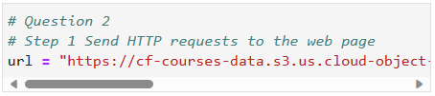

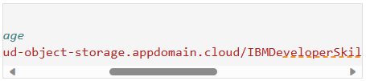

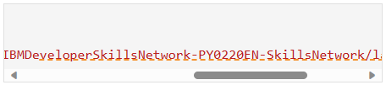

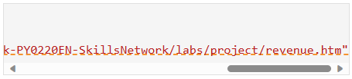

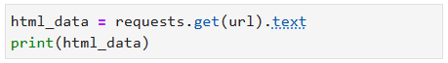

Parse the html data using beautiful_soup.



Using BeautifulSoup or the read_html function extract the table with Tesla Revenue and store it into a dataframe named tesla_revenue. The dataframe should have columns Date and Revenue.

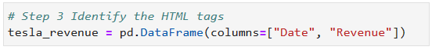

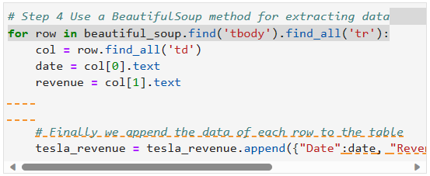

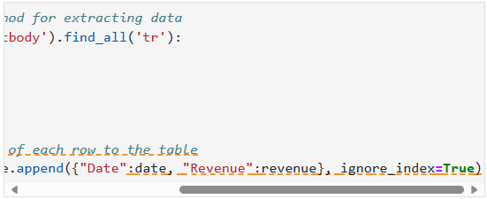

Execute the following line to remove the comma and dollar sign from the Revenue column.





Execute the following lines to remove an null or empty strings in the Revenue column.

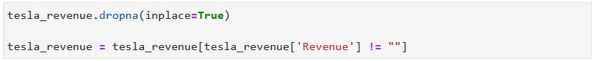

Display the last 5 row of the tesla_revenue dataframe using the tail function. Take a screenshot of the results.

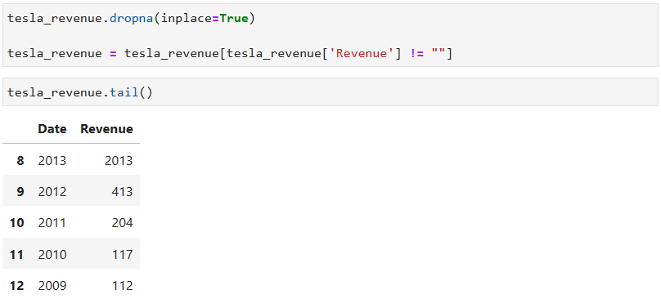

# **Question 3: Use *yfinance* to Extract Stock Data (Extracting GameStop Stock Data Using yfinance)**

Using the Ticker function enter the ticker symbol of the stock we want to extract data on to create a ticker object. The stock is GameStop and its ticker symbol is GME.



Using the ticker object and the function history extract stock information and save it in a dataframe named gme_data. Set the period parameter to max so we get information for the maximum amount of time.



**Reset the index** using the reset_index(inplace=True) function on the gme_data DataFrame and display the first five rows of the gme_data dataframe using the head function. Take a screenshot of the results and code from the beginning of Question 3 to the results below.





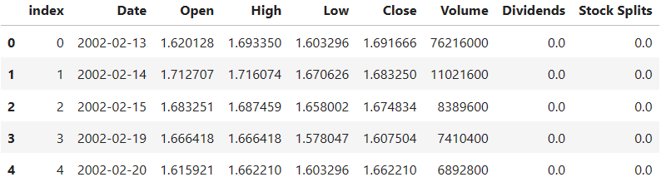

# **Question 4: Use Webscraping to Extract GME Revenue Data (Extracting GameStop Revenue Data Using Webscraping)**

Use the requests library to download the webpage <https://cf-courses-data.s3.us.cloud-object-storage.appdomain.cloud/IBMDeveloperSkillsNetwork-PY0220EN-SkillsNetwork/labs/project/stock.html>. Save the text of the response as a variable named html_data.

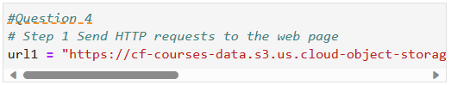

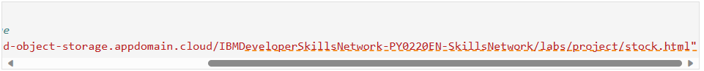



Parse the html data using beautiful_soup.



Using BeautifulSoup or the read_html function extract the table with GameStop Revenue and store it into a dataframe named gme_revenue. The dataframe should have columns Date and Revenue. Make sure the comma and dollar sign is removed from the Revenue column using a method similar to what you did in Question 2.



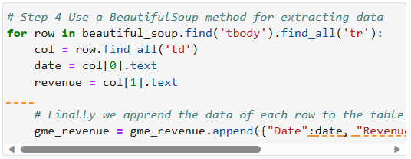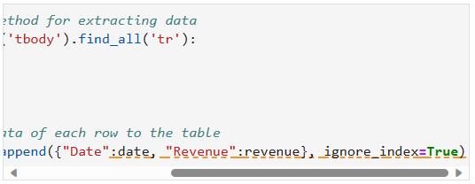



Display the last five rows of the gme_revenue dataframe using the tail function. Take a screenshot of the results.



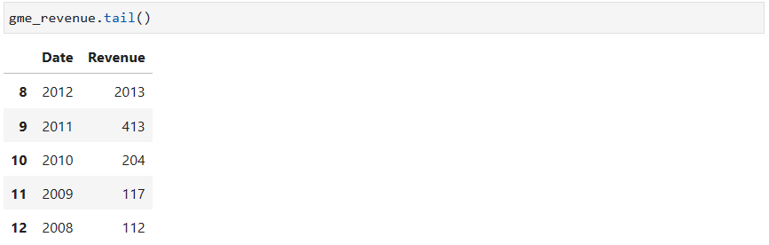

# **Question 5: Plot Tesla Stock Graph (Tesla Stock and Revenue Dashboard)**

Use the make_graph function to graph the Tesla Stock Data, also provide a title for the graph. The structure to call the make_graph function is make_graph(tesla_data, tesla_revenue, 'Tesla'). Note the graph will only show data upto June 2021.

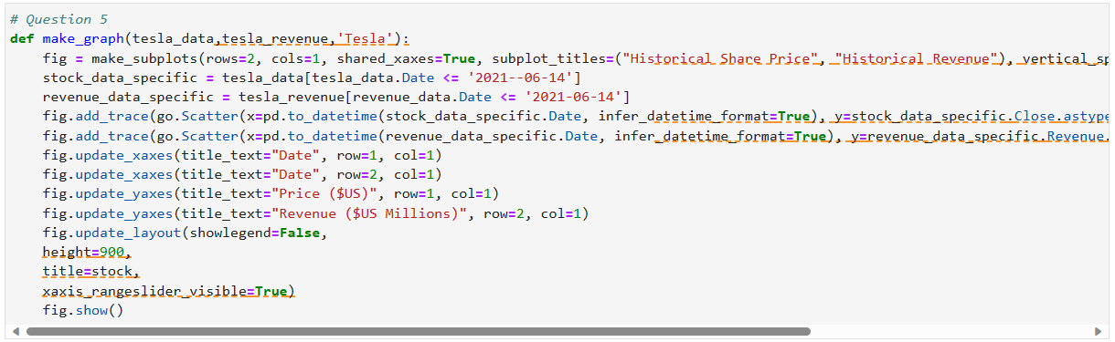

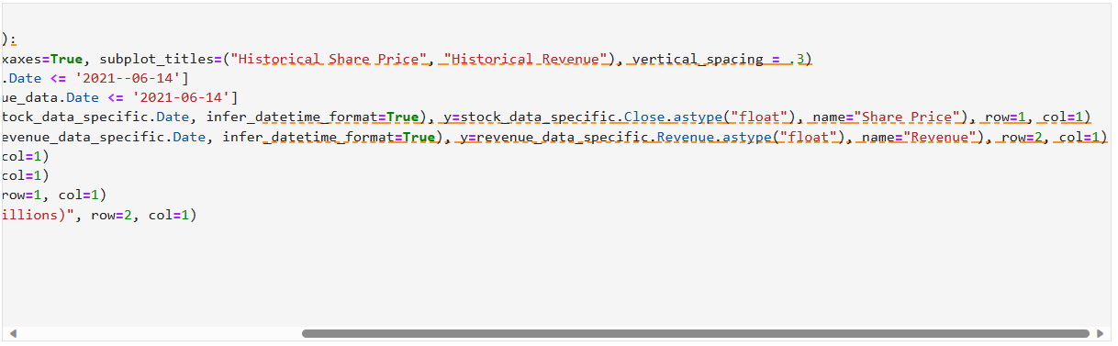

# **Question 6: Plot GameStop Stock Graph (GameStop Stock and Revenue Dashboard)**

Use the make_graph function to graph the GameStop Stock Data, also provide a title for the graph. The structure to call the make_graph function is make_graph(gme_data, gme_revenue, 'GameStop'). Note the graph will only show data upto June 2021.

